Lab 11

4 messages

2 Offer by host

2 Request by client

* + 1. because it has not been allocated and IP address for it yet

boardcast IP address 255.255.255.255 to look for servers sending it to any server

Sent over UDP

68 for client 67 for host

Client MAC address: Dell_4f:36:23 (00:08:74:4f:36:23)

DHCP sever address 192.168.1.101

Option: (1) Subnet Mask (255.255.255.0)

IP Address Lease Time: (86400s) 1 day

Router: 192.168.1.1

Domain Name: ne2.client2.attbi.com

Domain Name Server: 63.240.76.19

Domain Name Server: 204.127.198.19

Your (client) IP address: 192.168.1.101

Option: (50) Requested IP Address (192.168.1.101)

Since DHCP is dynamic it don’t give out permanent IP address unless it’s specified.

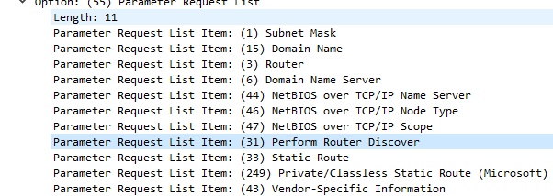

Client Server

Discover

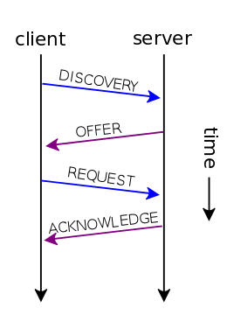

Offer

ARP

192.168.1.101 is at 00:08:74:4f:36:23

Because the connection shown is between the modem and 2 desktop

Dell_4f:36:23

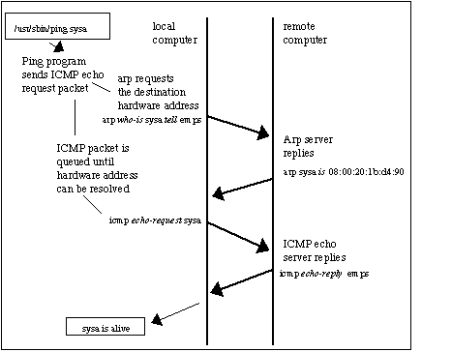

HTTP

Client

192.168.1.102

Host

128.119.245.12

TCP

[Full request URI: <http://gaia.cs.umass.edu/ethereal-labs/lab2-1.html>]

Version 1.1

User-Agent: Mozilla/5.0 (Windows; U; Windows NT 5.1; en-US; rv:1.0.2) Gecko/20021120 Netscape/7.01\r\n



Host: Identify the server to get the html document

Accept: Show all the file types and protocol that the browser of the client accept

Keep-alive: specify that theirs is more request to come and to keep the TCP connection open this including some parameter that can be modified

Connection: specify the type of the connection

Server: Apache/2.0.40

(Red Hat Linux)\r\n Linux

Cotent-length specify the html data in bytes

DNS

Source 128.238.38.160 3163

Dest 128.238.29.23 53

The client is sending a query to the DNS server to resolve the URL [www.ietf.org](http://www.ietf.org)

It gave two addresses 132.151.6.75

And 65.246.255.51

1678 second

UDP

DNS 2.0

It’s trying to find an address from another text URL because that address has been moved to another address

Name: 22.29.238.128.in-addr.arpa

22.29.238.128.in-addr.arpa: type PTR, class IN, dns-prime.poly.edu

Yes

The domain name server is a mailbox